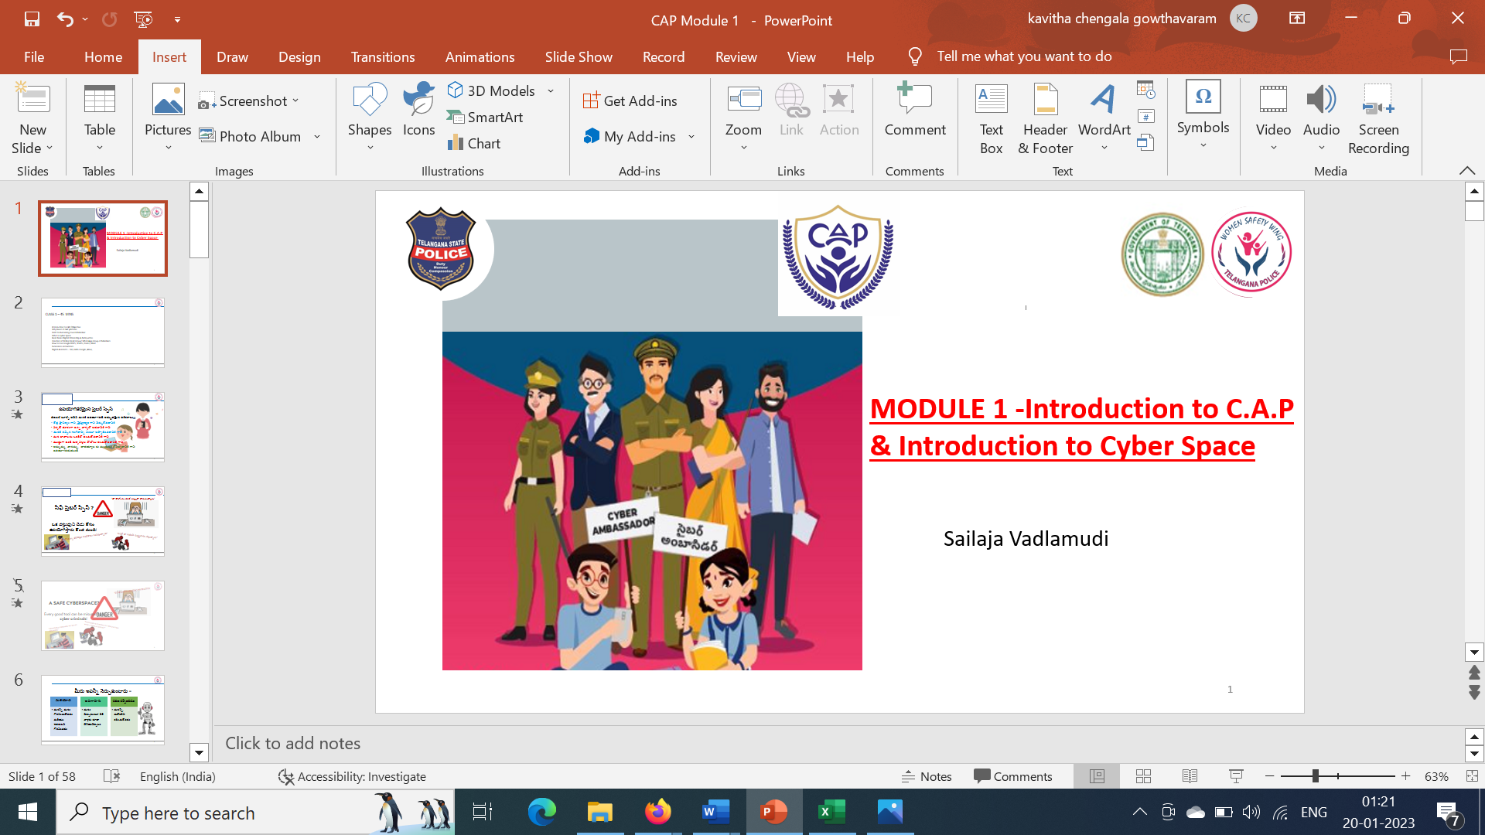****

**Module 4:** **Dos and Donts of cyber security - Incident Reporting and Incident Response LESSON PLAN**

**Learning Outcome**

|  |
| --- |
| On successful completion of the module, learners: |
| **Knowledge :** |
|  |
| |  | | --- | | * + - ·       List the do’s and Dont’s of cyber security | | * + - ·       Understanding the procedure to retrieve hacked accounts | | * Awareness on the preventive measures to safeguard accounts | | * + - ·       Know the Pocso act and Children rights     - Awareness on important help line numbers to report the cyber crimes | |
| **Skills :** |
| ·       Collaborate effectively with different stake holders like mentor teachers, trainers, she team officers, officer in charge, volunteer mentors |
| ·       Apply effective oral, written, and visual communication skills to create awareness on cyber safety |
| **Application of knowledge and skills :** |
| ·       Apply the skills and knowledge gained to be safe in cyber space by using the do’s and Don’ts learnt |
| ·       Demonstrate the skill to retrieve the hacked accounts and applying the preventive measures |
|  |

**LESSON PLAN ;**

|  |  |  |
| --- | --- | --- |
| **LESSON NAME /SUBTOPIC** | **MODE /TIME REQUIRED /PPT/ OTHER TEACHING TOOLS** | **EQUIPMENT REQUIRED /ACTIVITY /TIME** |
| Pre assessment | Pre assessment -5 questions (MCQ) to understand the knowledge of the students | **Zoom poll survey -5 min ..** |
| Creating awareness on the WOMEN SAFETY WING and district SHE TEAM OFFICERS group pic with names of each zone | Group pic of WOMEN SAFETY WING officers and District SHE TEAM OFFICERS pic | **PPT with 2 group pics with names -3 min** |
| Ice breaker - Punishments on cyber crimes -Gaddam mallesh gaaru – SI – cyber crimes -hyderabad- | Video on punishments and legal laws on cyber crimes | **Video – 6 min** |
| Cyber Security Do's and Dont's | Explaining the various aspects of cyber security through live site demonstrations and making Cyber ambassadors aware of the repercussions of the crime  Video by SHE team officer on how to report CRIME | **30 min** |
| Retrieving the Hacked Accounts and How to deal with them preventatives measures |
| Cyber Laws & their implications |
| Pocso act and children rights |
| Where & How to Report Cyber Crime |
| Post Assessment explanation | The timeline for completing the post assessment shall be given like an hour from the end of the session. Cyber Ambassador have to log in to the website and answer the questions. There are 10 questions pertaining to the syllabus. | **2 min** |
| Activity 1 and 2 Narration | Time line to complete this activity is 3 weeks from the time of completing the second module .Narration given below . | **3 min** |

**PREASSESMENT QUIZ QUESTIONS :**

**Mode : Zoom poll which can give the percentage of yes or no is used to assess the knowledge and experience of students in cyber space**   
**Questions :**

**POSTASSESMENT QUESTIONS**

**ACTIVITY IN CYBER AMBASSADOR PLATFORM (C.A.P)**

**CybHER # Cybersafe For Her**

**ACTIVITY TITLE 1 for module 4 : Visit the local Police station and get the interview of the police officer on how to report the cyber crime through a video and play this in the assembly before the students**

**PARTICIPANTS:** Cyber Ambassadors, SHE TEAM officers

**WHEN IS THIS DONE:** After the fourth module session the activity shall be finished within 2 weeks’ time

**MODUS OPERANDI: Visit the local PS and do an interview with SH team in charge on how to report the cyber crime .Write the script including these questions .**

**Take prior appointment confirming the interview time .Introduce yourself and the purpose of the visit .**

**Q1: I have identified the cyber crime , what should be the first step taken in reporting this ?**

**Q2 : Will all of us be safe when we report cyber crimes ?**

**Q3 : How will you assure that our identify is not revealed ?**

**Q4 : What is the timeline for resolving the case ?**

**Q5 : Thanking the Police Officer for the time**

**Let the video be not more than 3 to 4 minutes . showcase the interview to the students explaining your experience ( warm friendly and easy reach to report the crimes )**

**LANGUAGES**: English or any local language or bilingual as well

**ACTIVITY VIDEOS AND PICS** : To be shared with us through jot forms as and when provided

**OUTCOME OF THIS ACTIVITY:** To make students aware of the reporting of the cyber crimes

**ACTIVITY TITLE 2 FOR Module 4: Make a poster/ song / poem indicating the important help line numbers w.r.t to Safety and cyber security**

**PARTICIPANTS:** Cyber Ambassadors

**WHEN IS THIS DONE:** After the third module session the activity shall be finished within 2 weeks’ time

**MODUS OPERANDI:** Make a poster/ song / poem indicating the important help line numbers w.r.t to Safety and cyber security and display before the students explaining the importance of the numbers

**LANGUAGES**: English or any local language or bilingual as well

**ACTIVITY VIDEOS AND PICS** : To be shared with us through jot forms as and when provided

**OUTCOME OF THIS ACTIVITY:** To make students aware of the important numbers related to safety .